**WEEK 4**

**AIM:** Stack and its various applications

In this exercise, I made a menu-driven program where I gave the user 5 choices. First, 4 choices are 4 different operations on the stack i.e push, pop, search, print, and the last choice is to exit the program.

I have implemented stack using linked list.

**VARIABLES USED**

Node of linked list: node

Data in node: data

Link to next node: next

Start of the stack: top

Element to search: Elem

Element to push: data

Input element from file: data

Position of the number being searched: pos

Helper variable: choice,temp

Initial content of input file:

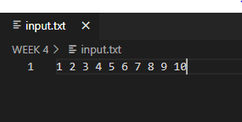

All four operations are explained below in detail:

1. Push: This function is used to push elements inside stack.

Time complexity: O(1)

Sample Input from file: 1, 2, 3, 4, 5, 6, 7, 8, 9, 10

Algorithm:

Step1. Get the value to be pushed in the stack in a varible data

Step2. Declare a temp variable of type pointer to node

Step3. temp->data=data;

Step4. temp->next=top;

Step5. top=temp

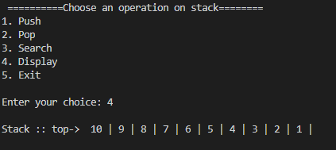



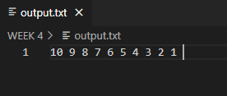

1. Pop: This function is used to remove the topmost element of stack.

Time complexity: O(1)

Sample Output: (10 popped from the stack)

Algorithm:

Step1. Declare a temp variable of type pointer to node and assign value of top to it.

Step2. If temp is null then it is the underflow condition.

Step3. top=top->next

Step4. free(temp)

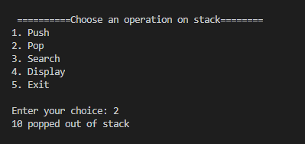

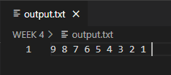

1. Search: This function is used to search an element in stack.

Time complexity: O(n)

Sampe Input: 5

Sample Output: Element 5 found at position 4

Sample input: 10

Sample out: Element 10 not found in stack

Algorithm:

Step1. Get the value to be searched in a varible elem

Step2. Declare a temp variable of type pointer to node and assign value of top to it.

Step3. pos=0

Step4. Run a loop till the end of the list and compare the data of the node with the value to be searched. Increment pos by one each time.

Step5. If they are equal, print the position and break the loop.

Step6. If temp is still null then number is not present.

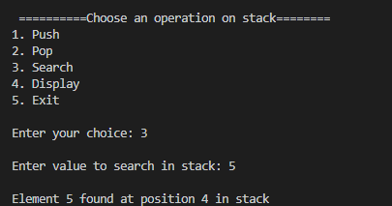

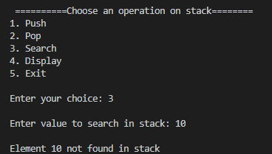

1. Print: This function is used to print the whole stack.

Sample Output: Stack: 9 8 7 6 5 4 3 2 1

Algorithm:

Step1. Declare a temp variable of type pointer to node and assign value of top to it.

Step2. If temp is null then the stack in empty.

Step3. Run a loop till the end of the list and keep printing the data.

Step4. End the loop when you reach the end of linked list.

